*jw*

***Team Introduction***

*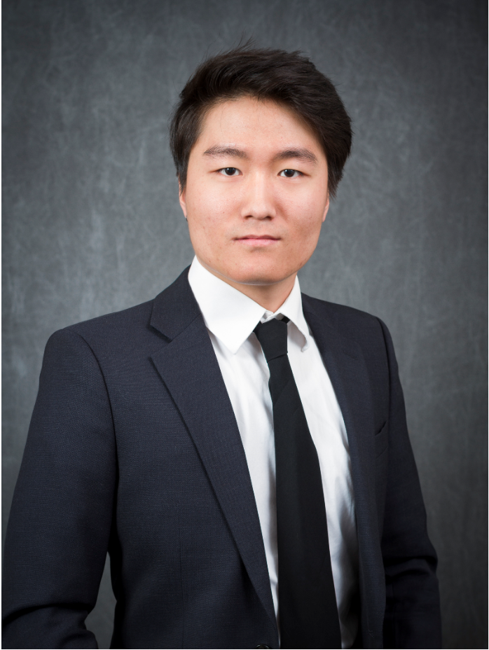JW*

***Introductions: Jisung***

My name is Yannan Zhu, I will be introducing my teammate, Jisung Woo. He is a well-spoken man, he is good at badminton and fancy watching soccer. Jisung is a natural-friendly person because he loves peaceful rural areas. According to Jisung’s answer, I have a thought that Jisung is a loyal and responsible person. He doesn’t like negative people, friends and family make him happy and his childhood dream is to be a teacher. Also, he would like to spend more time with friends and family when he has leisure time. In addition, he is a very patriotic person and so proud of his country. He loves singing Korean ballad songs and eating Korean BBQ. Last Thursday, Jisung and I were a temporary team. I noticed his email’s background is Korean national flag. Jisung is a respectable and honest person who loves his country with honor.

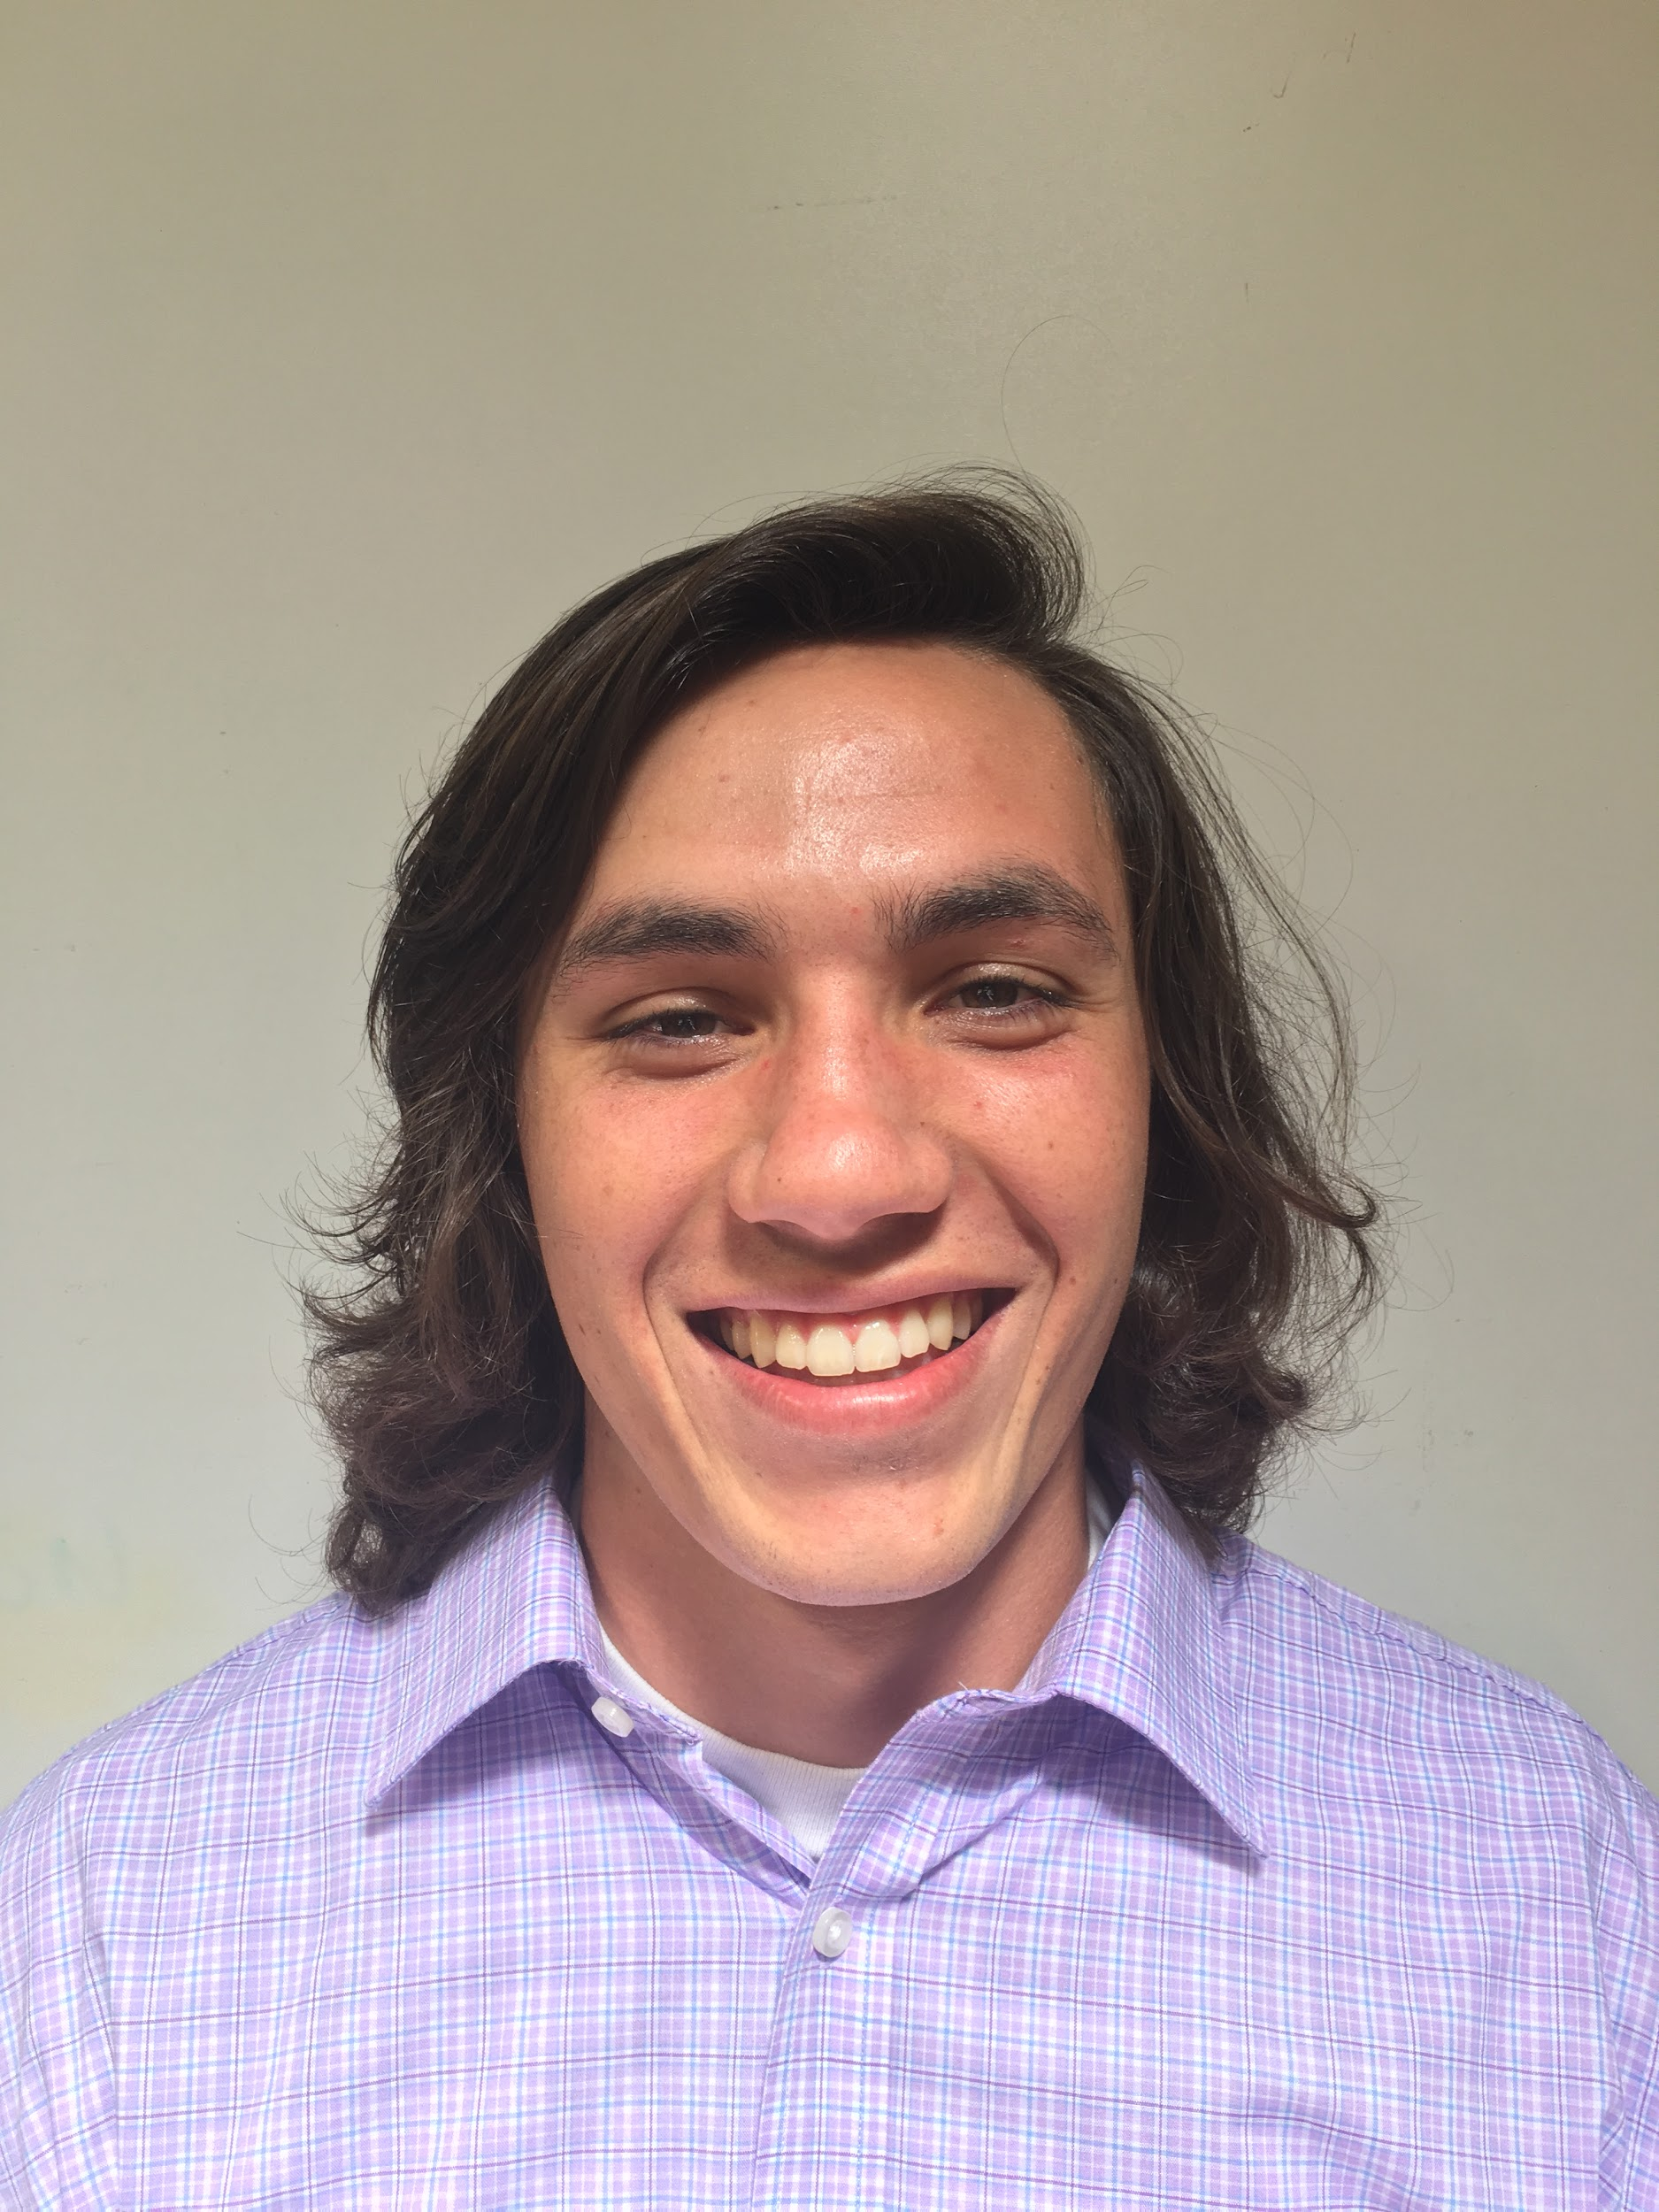

***Introductions: John***

My name is Zuhair and I’m introducing one of my team members, John but people call him Jip. Jip enjoys hiking, golfing and camping. He is an adventurous yet sporadic individual. John is so adventurous that he attempted a 20ft gainer. John is also a clean and organized person. He even works out a few times a week and plays frisbee to stay in shape. He undoubtedly enjoyed seeing Jon Bellion live more than any other performance he’s watched. Finally, if John could share coffee with any celebrity, it would be Shia Lebeouf. John is a hard working and dedicated team member. *ZR*

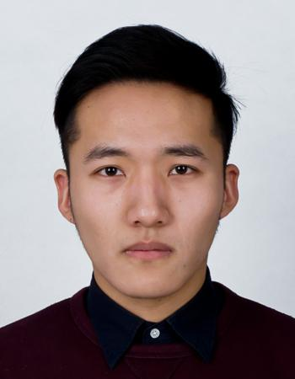

***Introduction: Yannan Zhu***

My name is Jisung Woo and I will be introducing my team member, Yannan Zhu. Some of his friends call him by his nickname, Daidai, but he usually goes by Derrik. He is a warmhearted person because although he is afraid of roller coasters, when he travels to the amusement park with his friends, he always waits for his friends by keeping his friend’s belongings safely. As a realist, he accepts the situation as it is and tries to deal with it accordingly by trying to overcome procrastination. He is a very active person. This can be shown by his love to travel and collections of railway tickets, flight tickets, and movie tickets. He is also a very motivated person as demonstrated by his preference to push himself to live his life rather than win the lottery. He is culturally advanced as he loves food from different countries. He loves Japanese food, Five Guys, and Hotpot. Lastly, as he only works in an organized and clean place, with his strong work ethic, his work will be very neatly organized. *JW*

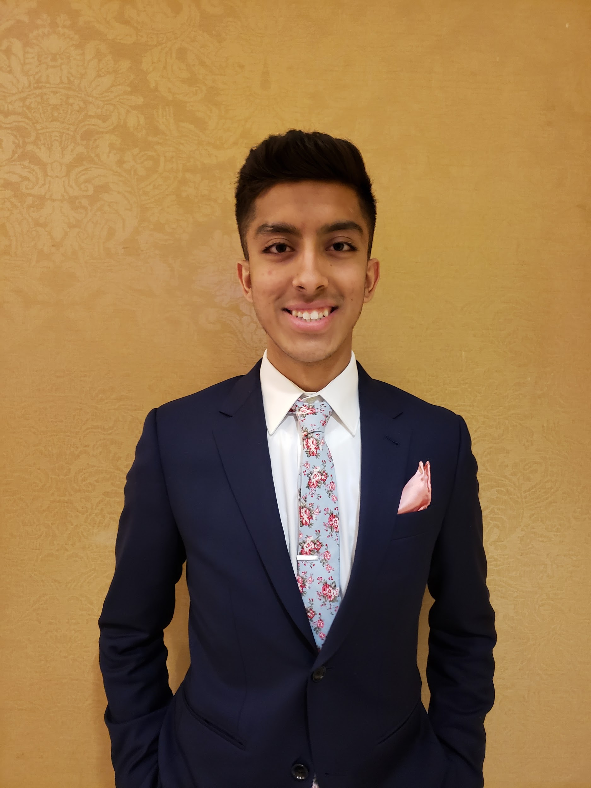

***Introductions: Zuhair***

My name is John and I will be introducing my teammate Zuhair. Those that are close to him call him Zu or even Zuzu. If his friends had to describe him in a word they would say that he is funny and outgoing. As a young kid, Zu wanted to play soccer professionally. Currently, Zu still enjoys playing soccer. He also enjoys hiking and lifting as other ways of staying in shape. He is also quite adventurous. He once even jumped off a forty foot bridge into the water below. Additionally, he has even eaten cow tongue before, although he would probably never do it again. His first job was as a sales associate at Tommy Hilfiger. Looking forward ten years in his life, Zu aspires to hold an executive IT position at a tech company. It is a very real possibility considering that Zu has a very strong work ethic. *JB*

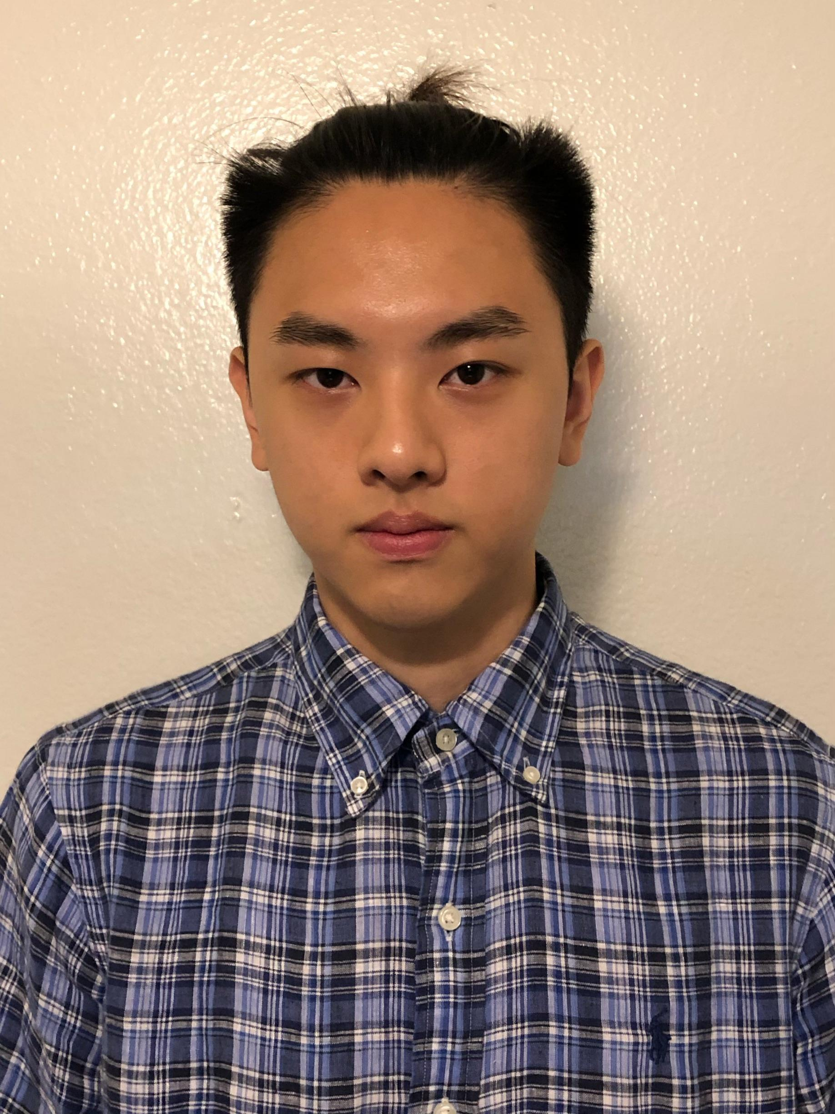

***Introductions: Kevin***

My name is Kevin Yang and I will be introducing myself. Although I am a laid-back person, I still take important tasks seriously. My biggest fear is regret, so I would make sure I do everything I can to prevent that. My life goal is to work until I make enough money for early retirement. I enjoy video games, anime, and movies in my free time. Like everyone else on this planet I also enjoy good food. I am open minded and would often embrace new things in life. People who knew me would describe me as a resourceful person because I can always find a way to resolve their problems. My mother is an artist, so I was taught to be artistic and creative with what I do in life. I am decent at making art and designs.

KY

**Team Membership Agreement for CIS 365**

**Team Sparky’s Finest #16 Charter/Code of Ethics**

We, the Sparky’s Finest team, having signed the attached Team Membership Agreement, have developed the following code of ethics to manage our project team activities. This Team Charter/Code specifies the minimum expectations of appropriate behavior for each team member, and will be used to evaluate any potential problems.

If, in the future, we determine that the rules specified in this document should be modified of supplemented, we may produce a revised version. At that time, the revised version will become effective, and the older version will be null.

**Code of Conduct:**  As a project team, we will:

* Make this project a priority
* Put the teams goals first
* Give our best effort towards this project

**Participation:** We will:

* Each do our fair share of work
* Be on time to class and team meetings
* Turn in work when communicated
* Be an active participant in team meetings

**Communication:** We will:

* Communicate efficiently and kindly
* Respond to group chat when necessary
* Inform team members if they will be absent for team meetings
* Let other team members know if we need help

**Problem Solving:** We will:

* Talks about any roadblocks as a team
* Find the best solution for any problems that we might face
* Work out problems as a team

**Meeting Guidelines:** We will:

* Be on time to meetings
* Come prepared to share ideas
* Be attentive during meetings
* Not use our phones unless needed

We, the undersigned, accept the conditions of team membership for CIS 365. The specific conditions of team membership are recorded in the Team Charter which we have developed and attached.

The Charter reflects the minimum level of performance that is expected of any group member. If a group member fails to meet this minimum level, they may be subject to the following consequences:

1. Send an apology letter to each of the team members with reason for letter
2. Go into an elevator and say “ Peter Piper Pizza”
3. Post a selfie with “I am so COOL!” on social media, and get 15 LIKE.
4. Buy a cup of coffee to everyone who participated in the meeting

**Project Team Name:** Sparky’s Finest

|  |  |  |
| --- | --- | --- |
| **Typed Name:** | **Signature:** | **Date:** |
| John Beguhl | John Beguhl | 9/12/2019 |
| Yannan Zhu | Yannan Zhu | 9/12/2019 |
| Jisung Woo | Jisung Woo | 9/12/2019 |
| Kevin Yang | Kevin Yang | 9/14/2019 |
| Zuhair Rauf | Zuhair Rauf | 9/15/2019 |

***TEAM PROFILE***

***Skills***

* Microsoft Office
* Java
* C/C++
* Visio
* Python
* My SQL
* Video editing

***Available Technology***

* Printer
* Scanner
* Laptops/PC
* Smartphone
* Camera
* Softbox light
* Shotgun mic
* Graphing Calculator
* 3D printer
* Laser cutter

*JB ZR jw*

***Meeting Times***

*ZR* JW *JB KY*

Wednesday 3:00 PM - 4:00 PM

Or

Thursday 4:00 PM - 5:00 PM

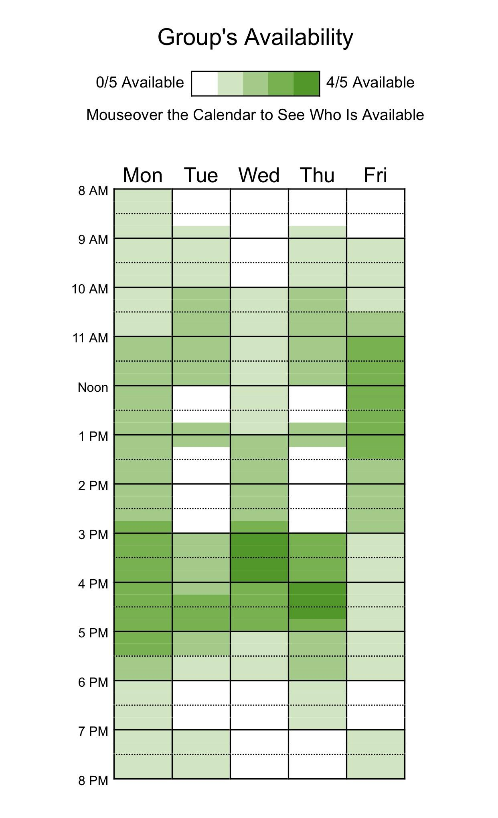

***Assigned Tasks***

**Facilitator:** Jisung Woo

**Fact Finder:** Yannan Zhu

**Follow Thru:** John Beguhl

**Implementor:** Kevin Yang

**Quick Start:** Zuhair Rauf

*JB ZR*

*KY JW*

***Resumes***

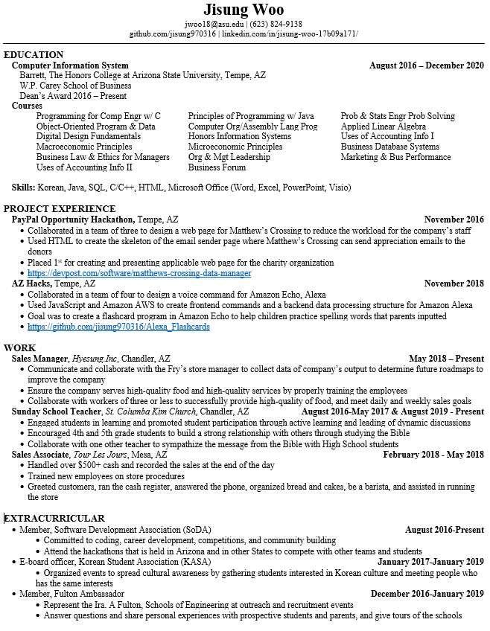***jw***

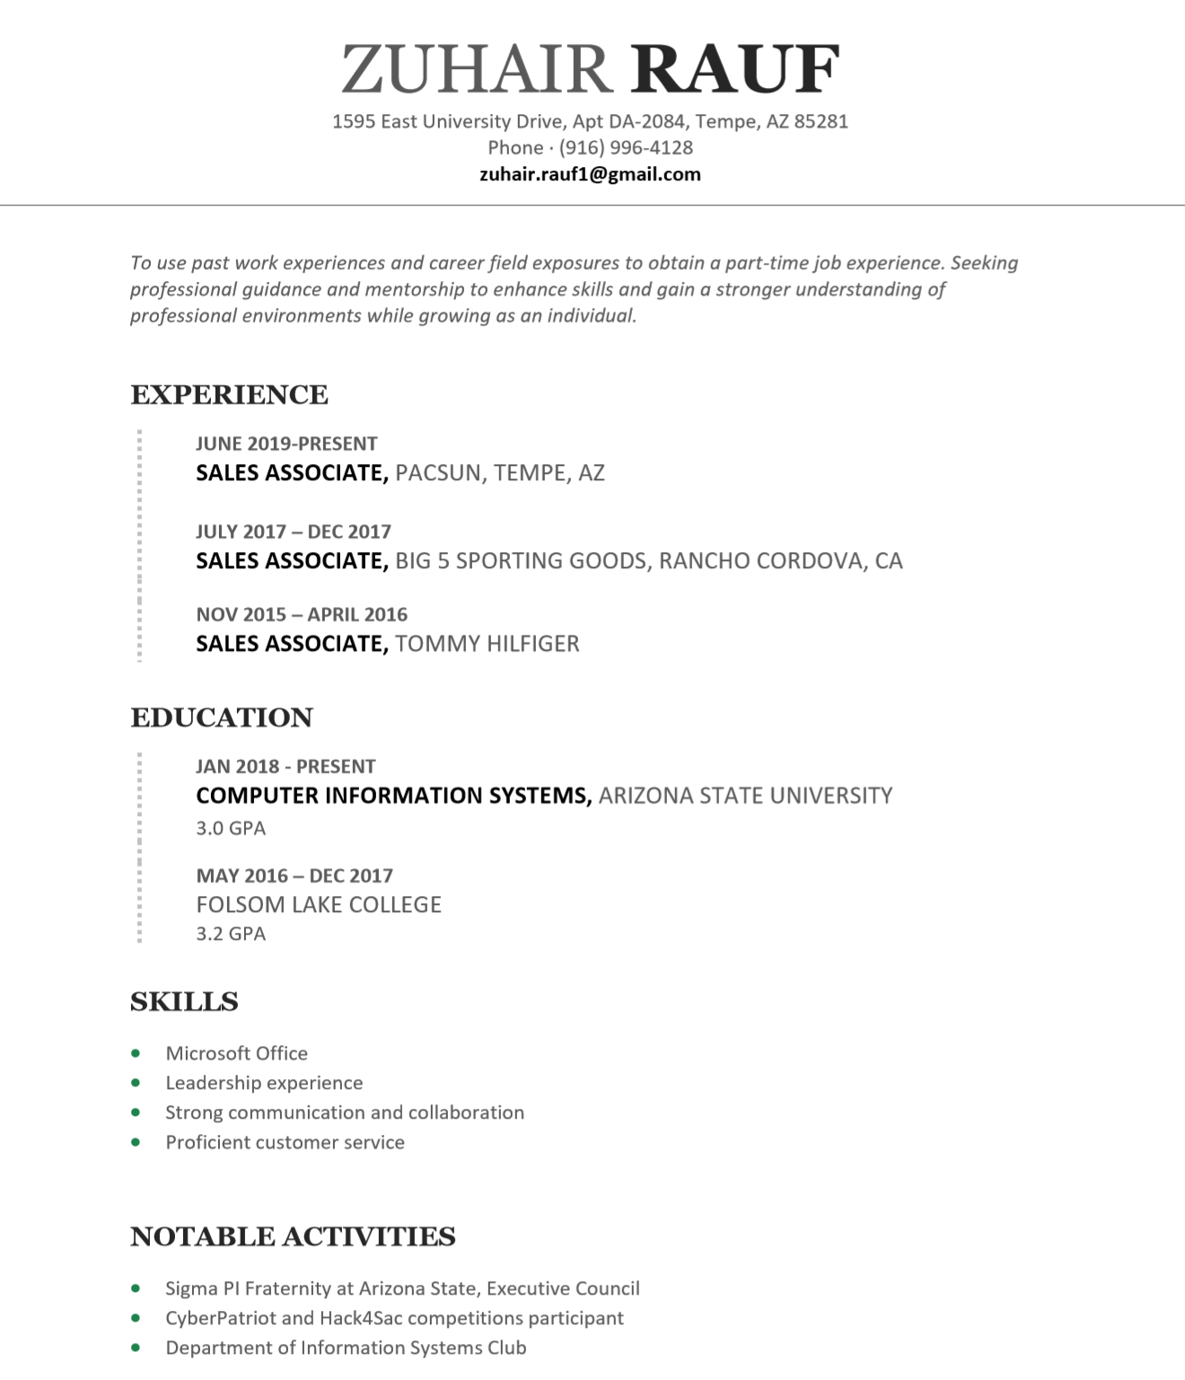

***zr***

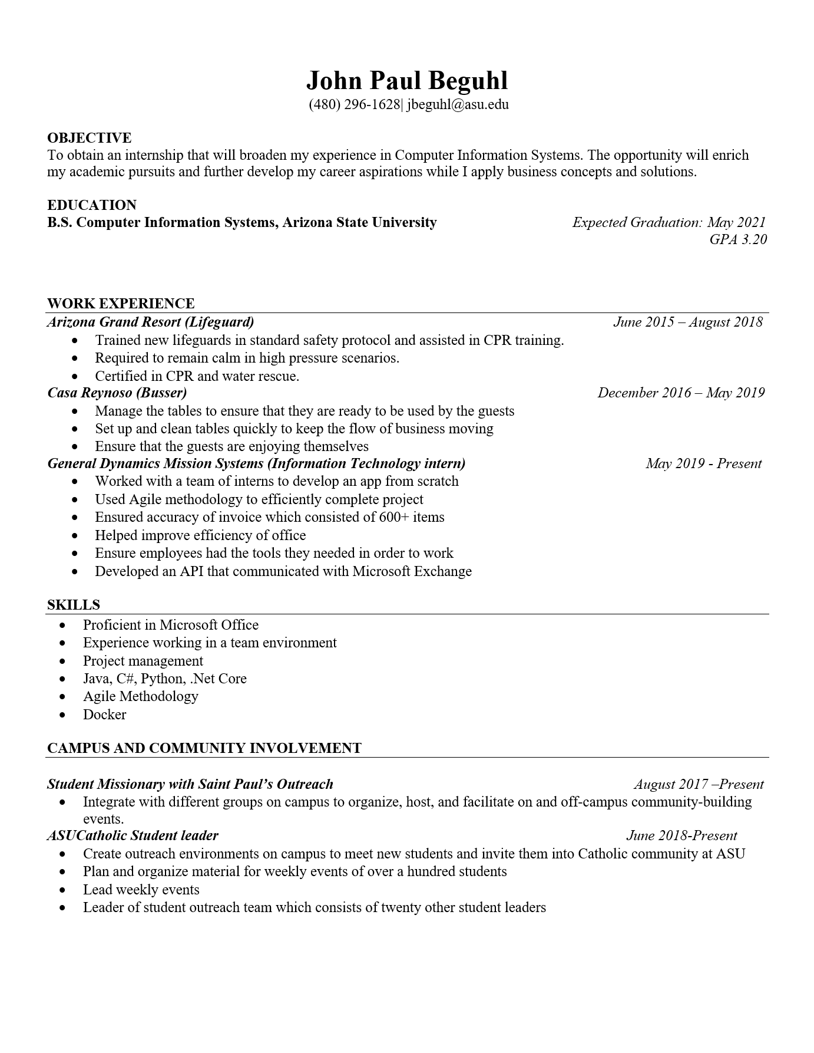

***jb***

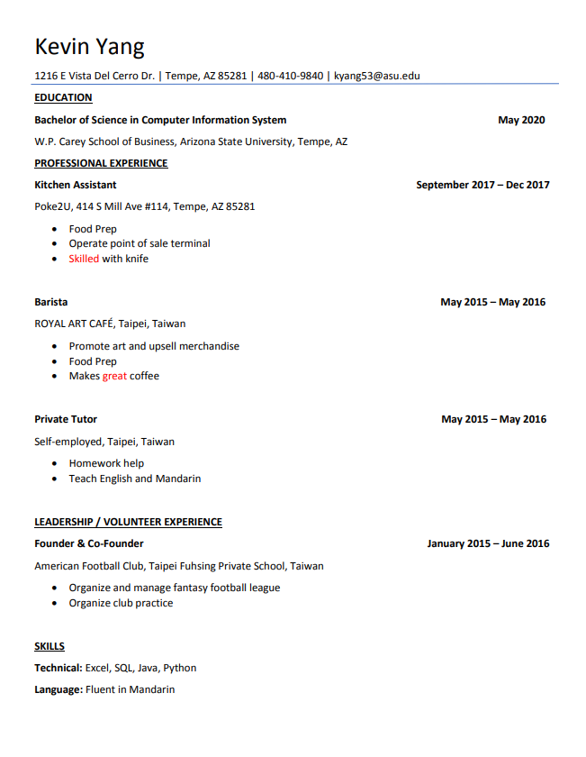***ky***

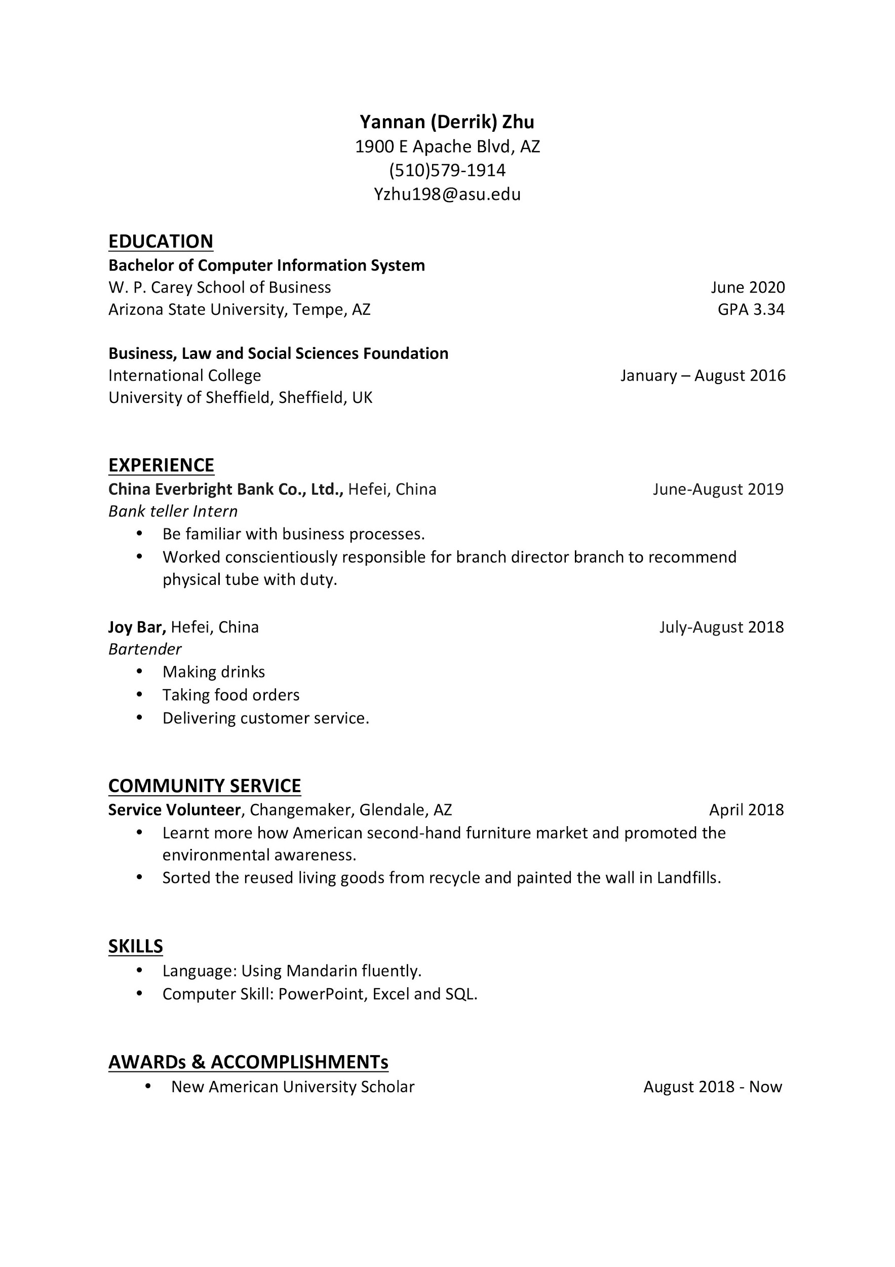yz

***Individual Journal Entries JW***

|  |  |  |
| --- | --- | --- |
| ***Team Member Name: Jisung Woo*** | | |
| ***Date of Work Performed*** | ***Description work performed*** | ***Time Spent on Work Performed (HRS)*** |
| 8/29/2019 | Gathered Team's information | 0.2 |
| 8/29/2019 | Created Milestone 1 Google Drive Folder and Document | 0.1 |
| 9/7/2019 | Answered 15 questions from "100 getting to know you questions" | 1 |
| 9/8/2019 | Wrote Yannan Zhu's introduction | 1 |
| 9/10/2019 | Had a team meeting (arrived late) | 0.17 |
| 9/10/2019 | Created Title Page and researched for suitable logo | 0.5 |
| 9/10/2019 | Created multiple documents, Agenda, Individual Journal Entries, Logo ideas, and resource Histogram | 2 |
| 9/11/2019 | Declared for chair position | 0.02 |
| 9/11/2019 | Edited Meeting Agenda for both 8/29/2019 and 9/10/2019 | 1.5 |
| 9/11/2019 | Updated and uploaded my resume and pictures | 0.75 |
| 9/11/2019 | Edited Team Profile section on Milestone one | 0.25 |
| 9/11/2019 | Updated Resource Histogram | 0.1 |
| 9/12/2019 | Reviewed and Signed Team Agreement | 0.2 |
| 9/13/2019 | Complete "when to meet" website | 0.083 |
| 9/14/2019 | Finalized Meeting Agendas | 0.5 |
| 9/14/2019 | Made sure if all documents are in correct format and correct font | 0.05 |
| 9/14/2019 | Added consequences section on Team Agreement document | 0.17 |
| 9/15/2019 | Finished "Assigned Tasks" section on Milestone 1 | 0.017 |
| 9/15/2019 | Wrote my initials on the pages that I've created and/or worked on | 0.17 |
| 9/15/2019 | Gave team warning on what is still missing from certain people and need in better communication | 0.17 |
| *Page created by jw* |  |  |
| *Page worked on by jw* |  | Total Hours for Jisung : 8.95 hours |

|  |  |  |
| --- | --- | --- |
| ***Team Member Name: Zuhair Rauf*** | | |
| ***Date of Work Performed*** | ***Description work performed*** | ***Time Spent on Work Performed (HRS)*** |
| 9/7/2019 | Answered questionaire | 0.5 |
| 9/8/2019 | Completed John's Intro | 0.5 |
| 9/10/2019 | Assisted with Team logo | 0.5 |
| 9/10/2019 | Met with team to discuss next steps | 0.5 |
| 9/11/2019 | Uploaded headshot/available times to meet | 0.25 |
| 9/12/2019 | Updated resume | 0.25 |
| 9/14/2019 | Updated assigned tasks and journal entries | 0.5 |
| 9/15/2019 | Signed team agreement and updated histogram/work | 0.75 |
|  |  | Total: 3.75 |

*ZR*

KY

|  |  |  |
| --- | --- | --- |
| ***Team Member Name: Kevin Yang*** | | |
| ***Date of Work Performed*** | ***Description work performed*** | ***Time Spent on Work Performed (HRS)*** |
| 9/6 2019 | Answered team questionnaire for member introduction | 1 |
| 9/10 2019 | Team meeting | 0.25 |
| 9/11 2019 | Write introduction for myself | 1 |
| 9/12 2019 | Team logo development (image editing) | 0.2 |
| 9/14 2019 | Update team profile | 0.1 |
| 9/14 2019 | Upload resume to team google doc | 0.2 |
| 9/14 2019 | Upload headshot to team google doc | 0.7 |
| 9/14 2019 | Update histogram | 0.1 |
| 9/14 2019 | Upload group availability schedule to team google doc | 0.2 |
| 9/14 2019 | Update assigned tasks on team google doc | 0.3 |
| 9/15 2019 | Create chart for team histogram | 0.5 |
| 9/15 2019 | Put initial on pages worked on | 0.25 |
| 9/15 2019 | Upload Journal Entry to team google doc | 0.1 |
| 9/15 2019 | Check font and formatting on document | 0.1 |
|  | Total Hours: | 5 |

|  |  |  |
| --- | --- | --- |
| ***Team Member Name: John Beguhl*** | | |
| ***Date of Work Performed*** | ***Description work performed*** | ***Time Spent on Work Performed (HRS)*** |
| 9/8/2019 | Filled out questionaire for team intros | 0.5 |
| 9/8/2019 | Wrote introduction for Zu | 0.45 |
| 9/10/2019 | Had a team meeting on next steps for Milestone 1 | 0.25 |
| 9/12/2019 | Updated resume | 0.6 |
| 9/12/2019 | uploaded resume to Milestone 1 with headshot | 0.15 |
| 9/12/2019 | Drafted team Charter | 0.85 |
| 9/12/2019 | Edited formating of Milestone 1 and provided feedback on logo | 0.25 |
| 9/12/2019 | Updated histogram | 0.1 |
| 9/12/2019 | Updated Meeting Agenda | 0.15 |
| 9/13/2019 | Created site to find meeting times | 0.2 |
| 9/15/2019 | Updated histogram | 0.1 |
| 9/15/2019 | Proofread Documents and initialed documents and uploaded journal entry | 0.4 |
|  | Total Hours | 4 |

***jb***

***Individual Journal Entries***

YZ

|  |  |  |
| --- | --- | --- |
| ***Team Member Name: Yannan Zhu*** | | |
| ***Date of Work Performed*** | ***Description work performed*** | ***Time Spent on Work Performed (HRS)*** |
| 9/8/2019 | Answered 15 questions about myself | 1 |
| 9/8/2019 | Wrote Jisung's introduction | 1 |
| 9/14/2019 | Upload the resume | 0.5 |
| 9/14/2019 | Upload the headshot | 0.5 |
| 9/14/2019 | Update histogram | 0.4 |
| 9/14/2019 | Update Agenda | 0.2 |
| 9/15/2016 | Updated assigned tasks and journal entries | 0.2 |
|  | Total hours: | 3.8 |

***Team Resource Histogram***

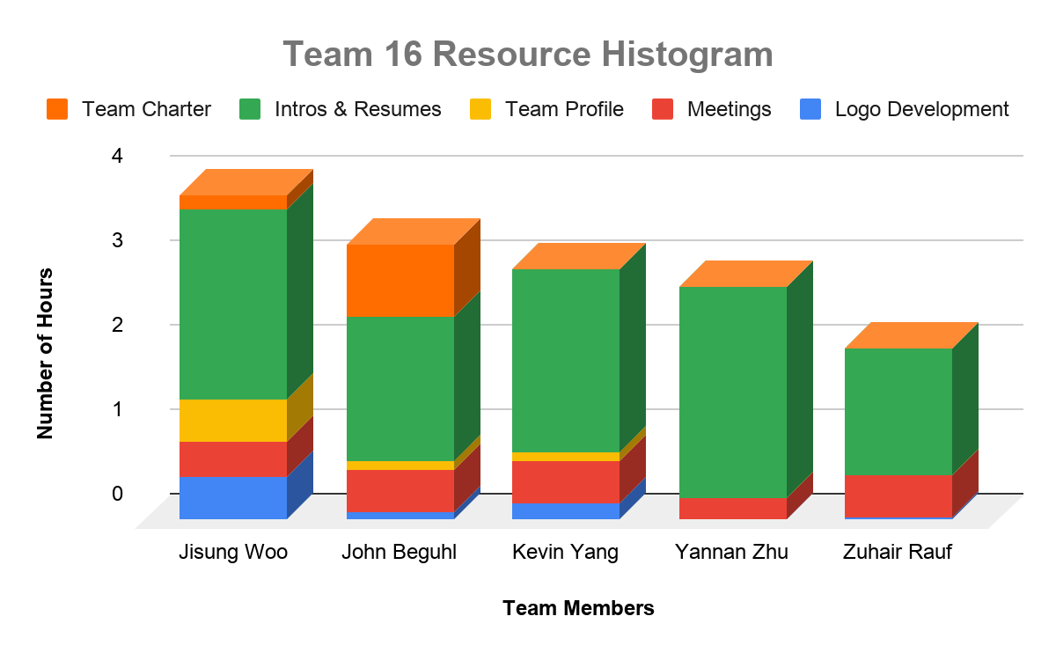

*JB JW**KY YZ* *ZR*

***Meeting Agendas***

**Date & Time: 8/29/2019 1:30 PM - 2:45 PM**

**Team Meeting for: (Sparky’s Finest #16)**

**Prepared by: (JW)**

**Client’s Name: (TBA)**

**Team members in attendance:**

**1. Jisung Woo 4. Yannan Zhu**

**2. John Beguhl 5. Zuhair Rauf**

**3. Kevin Yang 6.**

**Meeting Objective:** Get the project off to an effective start by introducing all team members, reviewing team goals, and discussing plans.

**Agenda:**

* Introductions of attendees
* Review of project background
* Review of project-related documents (i.e. project charter/code of ethics)
* Discussion of team member roles
* Gather contact information
* Download Group me
* List of action items from meeting

|  |  |  |
| --- | --- | --- |
| **Action Item** | **Assigned To** | **Due Date** |
| Team assigned and meeting | Everyone | 8/29/2019 |
| Do Introduction | Everyone | 9/8/2019 |
| Finalize the team name | Everyone | 9/8/2019 |
| Project Background Idea discussion (over text) | Everyone | 9/8/2019 |

**Time meeting ended: 2:47 PM**

**Date and time of next meeting: 9/10/2019**

**Date & Time: 9/10/2019 1:30 PM - 2:45 PM**

**Team Meeting for: (Sparky’s Finest #16)**

**Prepared by: (JW)**

**Client’s Name: (TBA)**

**Team members in attendance:**

**1. (Chair) - Jisung Woo 4. Zuhair Rauf**

**2. John Beguhl 5.**

**3. Kevin Yang 6.**

**Team members absent:**

1. **Yannan Zhu**

**Meeting Objective:** Have a brief discussion on what the team should improve and finish on Milestone 1.

**Agenda:**

* Discuss whether we should meet in person or use calling/texting app to have our next meeting
* Review progress and discuss on what to improve
* Set date to when to finish the works that is in progress
* Assigned someone to work on Team Membership Agreement

|  |  |  |
| --- | --- | --- |
| **Action Item** | **Assigned To** | **Due Date** |
| Team Meeting | Everyone | 9/10/2019 |
| Create other documents | Jisung | 9/10/2019 |
| Title Page | Jisung | 9/10/2019 |
| Find Title Page logo | Jisung | 9/10/2019 |
| Work on Meeting Agenda | Jisung | 9/12/2019 |
| Upload Professional Photo | Everyone | 9/11/2019 |
| Work on Resume section | Everyone | 9/11/2019 |
| Work on Resource Histogram | Everyone | 9/11/2019 |
| Work on Individual Journal Entries | Everyone | 9/15/2019 |
| Team Membership Agreement | John | 9/12/2019 |
| Sign Team Membership Agreement | Everyone | 9/12/2019 |
| Sign When2meet.com | Everyone | 9/13/2019 |
| Finalize both Meeting Agenda | Jisung | 9/14/2019 |
| Double check the rubric to see if we met every requirements | Jisung | 9/15/2019 |
| Finalize editing | Everyone | 9/15/2019 |
| Write initials on the pages created/worked on | Everyone | 9/15/2019 |
| Submit Milestone 1 | John Beguhl | 9/16/2019 |

**Time meeting ended: 1:30 PM**

**Date and time of next meeting: After Milestone 1 due date**

Jw jb